Sliding windowReport Issue

Like two pointers, sliding windows work the same with arrays and strings - the important thing is that they're iterables. For the sake of brevity, the first part of this article up until the examples will be focusing on arrays. However, all the logic is identical for strings.
Sliding window is another common approach to solving problems related to arrays. A sliding window is actually implemented using two pointers! Before we start, we need to talk about the concept of a subarray.

Subarrays
Given an array, a subarray is a contiguous section of the array. All the elements must be adjacent to each other in the original array and in their original order. For example, with the array [1, 2, 3, 4], the subarrays (grouped by length) are:
- Subarrays with length 1: [1], [2], [3], [4]
- Subarrays with length 2: [1, 2], [2, 3], [3, 4]
- Subarrays with length 3: [1, 2, 3], [2, 3, 4]
- Subarrays with length 4: [1, 2, 3, 4]
A subarray can be defined by two indices, the start and end. For example, with [1, 2, 3, 4], the subarray [2, 3] has a starting index of 1 and an ending index of 2. Let's call the starting index the left bound and the ending index the right bound. Another name for subarray in this context is "window".
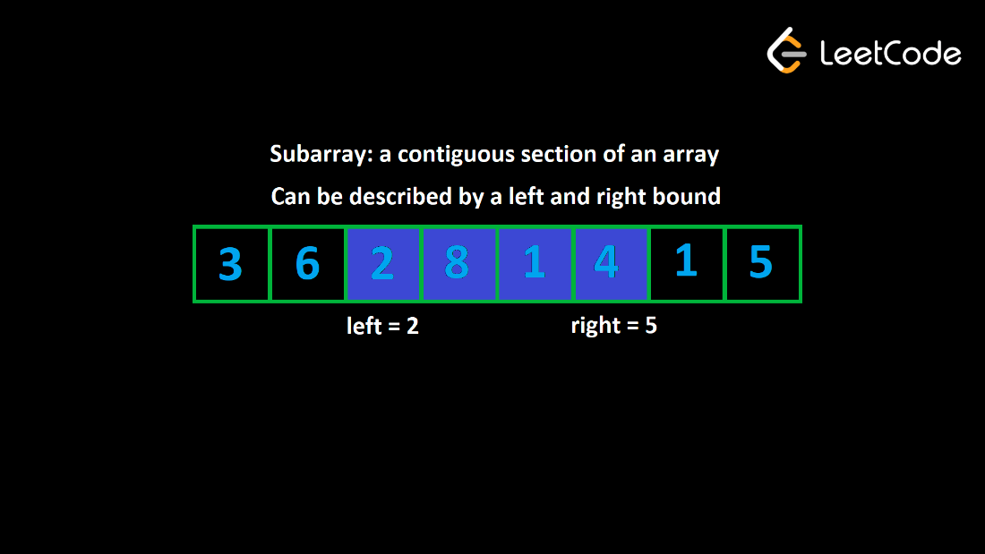

"Valid" subarrays
A common pattern you'll see in array problems involves the idea of a "valid" subarray. The problem description will either explicitly or implicitly define what makes a subarray "valid". We can split it into two parts:
- A constraint metric. This is an attribute of a subarray. - For example, the sum of the subarray, the number of unique elements in the subarray, the frequency of a specific element, etc.
- A numeric restriction on the constraint metric.
For example, let's say a problem declares a subarray is valid if it has a sum less than or equal to 10. The constraint metric here is the sum of the subarray, and the numeric restriction is <= 10. A subarray is considered valid if its constraint metric conforms to the numeric restriction, i.e., the sum is less than or equal to 10.

The idea
Sliding window is used to analyze and find the valid subarrays of an array. The idea behind a sliding window is to maintain two variables, left and right. At any given time, left represents the left bound of our window, and right represents the right bound of our window. Remember that "window" here is another word for subarray.
Initially, we set left = right = 0, which means that the first window we consider is just the first element of the array on its own. We want to expand the size of our "window", and we do that by incrementing right. When we increment right, this is like "adding" a new element to our window.
But what if after adding a new element, the subarray becomes invalid? For example, let's say adding a new element on the right makes the sum of the subarray too large. We need to "remove" some elements from our window until it becomes valid again. To "remove" elements, we can increment left, which shrinks our window.
Remember: left and right represent the bounds of our window at any given time, so incrementing left is equivalent to removing the left-most element.
As we add and remove elements, we are "sliding" our window along the input. The window's size is constantly changing - it grows as large as it can until it's invalid, and then it shrinks until it's valid once more. However, it always slides along to the right until it reaches the end of the input.
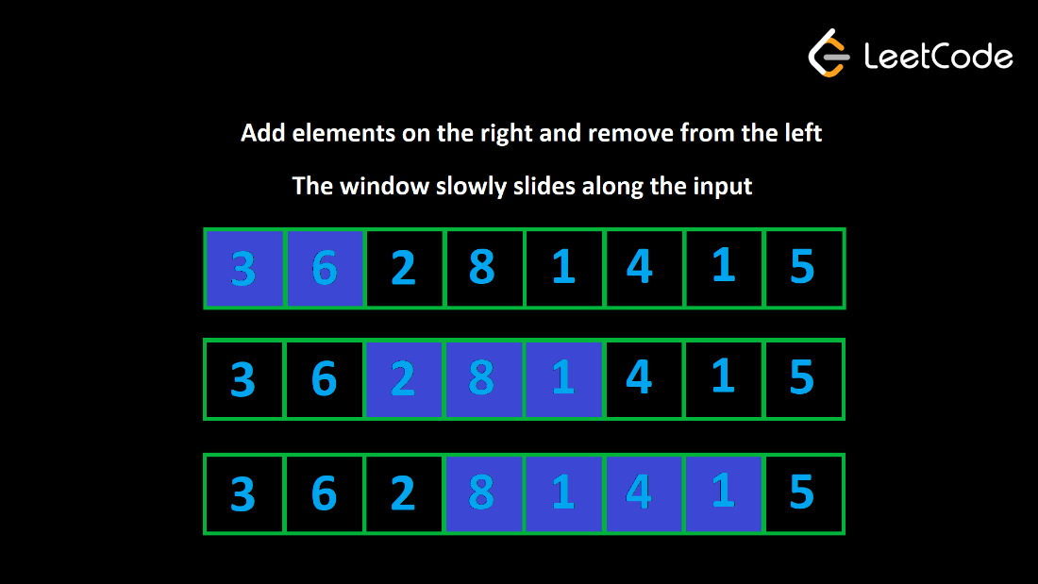
To explain why this algorithm works, let's look at a specific example. Let's say that we are given a positive integer array nums and an integer k. We need to find the length of the longest subarray that has a sum less than or equal to k. For this example, let nums = [3, 2, 1, 3, 1, 1] and k = 5.
Initially, we have left = right = 0, so our window is only the first element: [3]. Now, let's expand to the right until the constraint is broken. This will occur when left = 0, right = 2, and our window is: [3, 2, 1]. The sum here is 6, which is greater than k. We must now shrink the window from the left until the constraint is no longer broken. After removing one element, the window becomes valid again: [2, 1].
Why is it correct to remove this 3 and forget about it for the rest of the algorithm? Because the input only has positive integers, a longer subarray directly equals a larger sum. We know that [3, 2, 1] already results in a sum that is too large. There is no way for us to ever have a valid window again if we keep this 3 because if we were to add any more elements from the right, the sum would only get larger, and it's not like we can include the 3 without also including the 2 or 1, since that would violate the definition of a subarray. That's why we can forget about the 3 for the rest of the algorithm.

Solving problems with sliding window
Whenever you see a problem that not only describes subarrays being "valid", but also asks you to find these subarrays, you should immediately think about sliding window.
Often, the problem will ask you to find the best valid subarray. The problem will define what makes one subarray better than another. For example, a problem might ask you to find the longest valid subarray.
Another common type of problem is one that asks you to find the number of valid subarrays. We will take a deeper look at this type of problem later in the article.
Here is a preview of some of the example problems that we will look at in this article, to help you better understand what sliding window problems look like:
- Find the longest subarray with a sum less than or equal to k (constraint metric = sum)
- Find the longest substring that has at most one "0" (constraint metric = number of zeroes)
- Find the number of subarrays that have a product less than k (constraint metric = product)

Implementation
Now that you have an idea of how sliding window works, let's talk about how to implement it. For this section, we will use the previous example (find the longest subarray with a sum less than or equal to k).
First, we need to identify the constraint metric. In our example, the constraint metric is the sum of the window. How do we keep track of the sum of the window as elements are added and removed? One way that we could do it is by keeping the window in a separate array. When we add elements from the right, we add them to our array. When we remove elements from the left, we remove the corresponding elements from the array. This way, we can always find the sum of our current window just by summing the elements in the separate array.
This is very inefficient as removing elements and finding the sum of the window will be $O(n)$ operations. How can we do better?
We don't actually need to store the window in a separate array. All we need is some variable, let's call it curr, that keeps track of the current sum. When we add a new element from the right, we just do curr += nums[right]. When we remove an element from the left, we just do curr -= nums[left]. This way, all operations are done in $O(1)$.
Notice here that our window only exists as an idea. We are not literally maintaining it with an array. We only need left and right to remember its bounds, and curr to track the constraint metric.
Next, how do we move the pointers left and right? Remember, we want to keep expanding our window, and the window always slides to the right - it just might shrink a few times along the way . Because right is always moving forward, we can use a for loop to iterate right over the input. In each iteration of the for loop, we will be adding the element nums[right] to our window.
What about left? When we move left, we are shrinking our window. We only shrink our window when it becomes invalid. By maintaining curr, we can easily tell if the current window is valid simply by checking its value. If curr > k, the window is invalid.
Let's say nums = [1, 1, 1, 3] and k = 3. When we arrive at the 3 and add it to the window, the window becomes invalid, and curr will be equal to 6. We need to remove three elements from the left before the window becomes valid again.
This suggests that we should use a while loop to perform the removals. The condition will be while curr > k ("while the window is invalid"). To perform the removals, we do curr -= nums[left] and then increment left in each iteration of the while loop.
We now have a systematic way to slide our window across the input while maintaining its validity. How do we update the answer? In each for loop iteration, after the while loop, we know the current window is valid. We can write code here to update the answer. The formula for the length of a window is right - left + 1 (remember this formula).
Here's some pseudocode that puts it all together:
function fn(nums, k):
left = 0
curr = 0
answer = 0
for (int right = 0; right < nums.length; right++):
curr += nums[right]
while (curr > k):
curr -= nums[left]
left++

answer = max(answer, right - left + 1)

return answer
Here's some pseudocode for a general template:
function fn(arr):
left = 0
for (int right = 0; right < arr.length; right++):
Do some logic to "add" element at arr[right] to window

while WINDOW_IS_INVALID:
Do some logic to "remove" element at arr[left] from window
left++

Do some logic to update the answer

Why is sliding window efficient?
For any array, how many subarrays are there? If the array has a length of n, there are n subarrays of length 1. Then there are n - 1 subarrays of length 2 (every index except the last one can be a starting index), n - 2 subarrays of length 3 and so on until there is only 1 subarray of length n. This means there are $\sum_{k=1}^{n}{k}=\frac{n⋅(n+1)}{2}$ subarrays (it's the partial sum of this series).
In terms of time complexity, any algorithm that looks at every subarray will be at least $O(n^{2})$, which is usually too slow. A sliding window guarantees a maximum of $2n$ window iterations - the right pointer can move $n$ times and the left pointer can move $n$ times. This means if the logic done for each window is $O(1)$, sliding window algorithms run in $O(n)$, which is much faster.
You may be thinking: there is a while loop inside of the for loop, isn't the time complexity $O(n^{2})$? The reason it is still $O(n)$ is that the while loop can only iterate $n$ times in total for the entire algorithm (left starts at 0, only increases, and never exceeds n). If the while loop were to run n times on one iteration of the for loop, that would mean it wouldn't run at all for all the other iterations of the for loop. This is what we refer to as amortized analysis - even though the worst case for an iteration inside the for loop is $O(n)$, it averages out to $O(1)$ when you consider the entire runtime of the algorithm.
Now let's look at some sliding window examples.

Example 1: Given an array of positive integers nums and an integer k, find the length of the longest subarray whose sum is less than or equal to k. This is the problem we have been talking about above. We will now formally solve it.
Let's use an integer curr that tracks the sum of the current window. Since the problem wants subarrays whose sum is less than or equal to k, we want to maintain curr <= k. Let's look at an example where nums = [3, 1, 2, 7, 4, 2, 1, 1, 5] and k = 8.
The window starts empty, but we can grow it to [3, 1, 2] while maintaining the constraint. However, after adding the 7, the window's sum becomes too large. We need to tighten the window until the sum is below 8 again, which doesn't happen until our window looks like [7]. When we try to add the next element, our window again becomes too large, and we need to remove the 7 which means we have [4]. We can now grow the window until it looks like [4, 2, 1, 1], but adding the next element makes the sum too large. We remove elements from the left until it fits the constraint again, which happens at [1, 1, 5]. The longest subarray we found was [4, 2, 1, 1] which means the answer is 4.
When we add an element to the window by moving the right bound, we just do curr += value. When we remove an element from the window by moving the left bound, we just do curr -= value. We should remove elements so long as curr > k.
Click here for a more detailed explanation if needed
To summarize what each variable does in the code:
- left: the leftmost index of our current window
- right: the rightmost index of our current window
- curr: the sum of our current window
- ans: the length of the longest valid window we have seen so far
Iterate right over the input to add elements to the window. Maintain the sum of the window in curr by adding nums[right] to it. When the window becomes invalid (curr > k), remove elements from the window by subtracting nums[left] from curr and incrementing left. We need to do this until the window becomes valid again, so we use a while loop.
The size of a window is right - left + 1. Update our answer only once the window becomes valid.
If you're still having trouble understanding the algorithm, review the sections of this article before the example along with the video walkthrough.
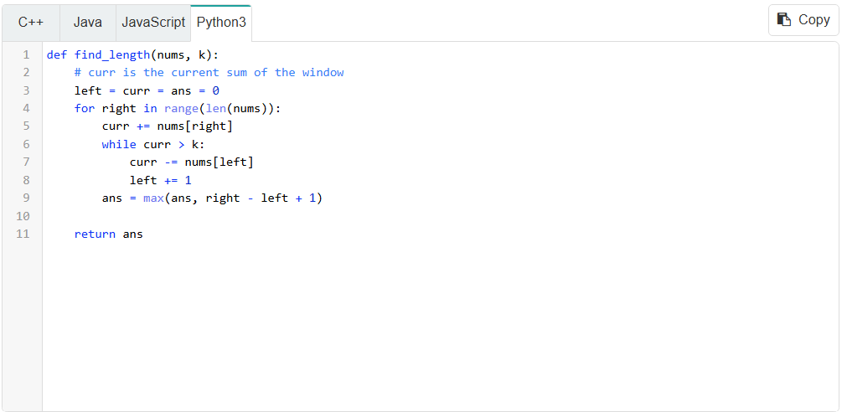
Given a subarray starting at left and ending at right, the length is right - left + 1. As mentioned before, this algorithm has a time complexity of $O(n)$ since all work done inside the for loop is amortized $O(1)$, where $n$ is the length of nums. The space complexity is constant because we are only using 3 integer variables.

Example 2: You are given a binary string s (a string containing only "0" and "1"). You may choose up to one "0" and flip it to a "1". What is the length of the longest substring achievable that contains only "1"?
For example, given s = "1101100111", the answer is 5. If you perform the flip at index 2, the string becomes 1111100111.
Because the string can only contain "1" and "0", another way to look at this problem is "what is the longest substring that contains at most one "0"?". This makes it easy for us to solve with a sliding window where our condition is window.count("0") <= 1. We can use an integer curr that keeps track of how many "0" we currently have in our window.
Click here for a more detailed explanation if needed
The input can only contain "1" or "0". We want to find the max consecutive "1". Because any element that isn't a "1" is a "0", this problem is equivalent to "what is the longest substring with at most one "0", since we could just flip that "0" and it's guaranteed every other character in the substring would be a "1".
Notice that the problem is asking for the length of a substring, and also has defined what makes a substring valid. The constraint metric is "how many 0s are in the substring". The numeric restriction is <= 1. Therefore, if we use an integer curr to track the constraint metric, the condition to determine if a window is valid is curr <= 1.
We can use the exact same process as in the previous example now. We iterate over the elements with a pointer right. At each element, if s[right] is equal to "1", we don't need to do anything. If it's equal to "0", we increment curr.
Whenever the window becomes invalid (curr > 1), we remove elements from the left. If s[left] == "0", then we can decrement curr. We increment left to remove elements.
Again, the size of a window is right - left + 1. We update our answer with this value after the while loop because the window is guaranteed to be valid.
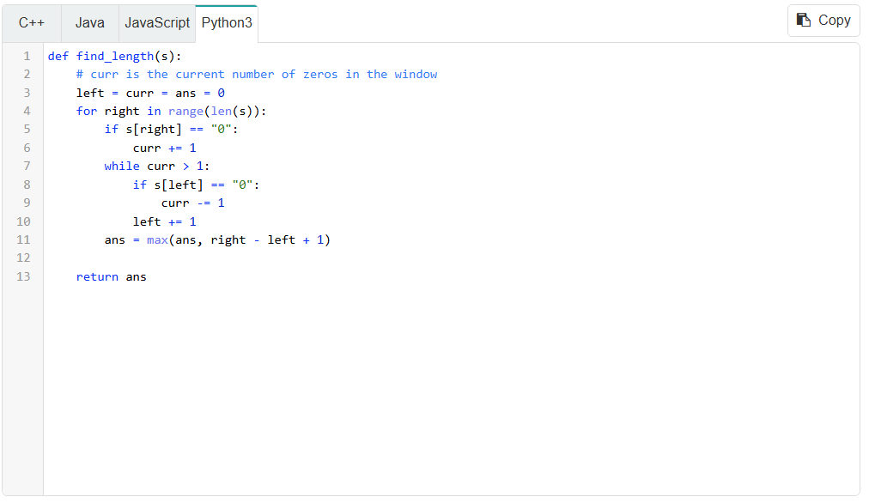
Like the previous example, this problem runs in $O(n)$ time, where $n$ is the length of s, as the work done in each loop iteration is amortized constant. Only a few integer variables are used as well, which means this algorithm uses $O(1)$ space.

Number of subarrays
If a problem asks for the number of subarrays that fit some constraint, we can still use sliding window, but we need to use a neat math trick to calculate the number of subarrays.
Let's say that we are using the sliding window algorithm we have learned and currently have a window (left, right). How many valid windows end at index right?
There's the current window (left, right), then (left + 1, right), (left + 2, right), and so on until (right, right) (only the element at right).
You can fix the right bound and then choose any value between left and right inclusive for the left bound. Therefore, the number of valid windows ending at index right is equal to the size of the window, which we know is right - left + 1.
Example 3: 713. Subarray Product Less Than K.
Given an array of positive integers nums and an integer k, return the number of subarrays where the product of all the elements in the subarray is strictly less than k.
For example, given the input nums = [10, 5, 2, 6], k = 100, the answer is 8. The subarrays with products less than k are:
[10], [5], [2], [6], [10, 5], [5, 2], [2, 6], [5, 2, 6]
To demonstrate the property we have just learned, let's look at the example in the description. When we reach index 2, the product becomes too large, so we need to remove the leftmost element 10. Now, the window is valid, and it has a length of 2. That means that there are 2 valid subarrays that end here ([2] and [5, 2]).
Recall that in the previous examples, we updated the answer (longest length) after the while loop, when the window must be valid. Here, we can add the current size of the window to our answer instead. The constraint that determines if a window is valid is that the product is less than k.
Additionally, note that if k <= 1 we can never have any valid windows, so we can just return 0 immediately.
Click here for a more detailed explanation if needed
The constraint metric is: product of the window. The numeric restriction is < k. If we use an integer curr to represent the current product of the window, the condition that makes a window invalid is curr >= k.
Add elements to the window with curr *= nums[right]. Remove them with curr /= nums[left].
After the while loop, we know the window is valid. Add the window size right - left + 1 to our answer.
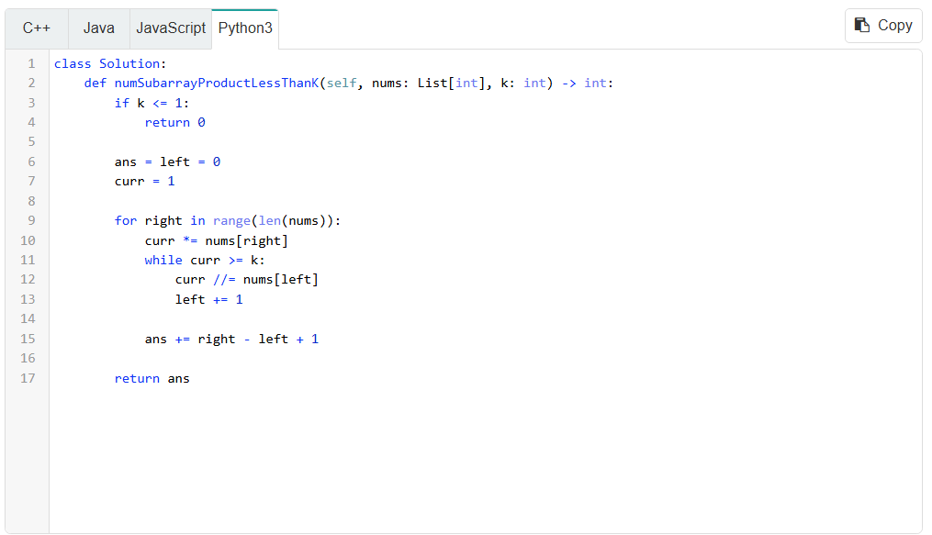
Again, the work done in each loop iteration is amortized constant, so this algorithm has a runtime of $O(n)$, where $n$ is the length of nums, and $O(1)$ space.

Fixed window size
In the examples we looked at above, our window size was dynamic. We tried to expand it to the right as much as we could while keeping the window within some constraint and removed elements from the left when the constraint was violated. Sometimes, a problem will specify a fixed length k.
These problems are easy because the difference between any two adjacent windows is only two elements (we add one element on the right and remove one element on the left to maintain the length).
Start by building the first window (from index 0 to k - 1). Once we have a window of size k, if we add an element at index i, we need to remove the element at index i - k. For example, k = 2 and you currently have elements at indices [0, 1]. Now, we add 2: [0, 1, 2]. To keep the window size at k = 2, we need to remove 2 - k = 0: [1, 2].
Here's some pseudocode:
function fn(arr, k):
curr = some data to track the window

// build the first window
for (int i = 0; i < k; i++)
Do something with curr or other variables to build first window

ans = answer variable, probably equal to curr here depending on the problem
for (int i = k; i < arr.length; i++)
Add arr[i] to window
Remove arr[i - k] from window
Update ans

return ans

Example 4: Given an integer array nums and an integer k, find the sum of the subarray with the largest sum whose length is k.
As we mentioned before, we can build a window of length k and then slide it along the array. Add and remove one element at a time to make sure the window stays size k. If we are adding the value at i, then we need to remove the value at i - k.
After we build the first window we initialize our answer to curr to consider the first window's sum.
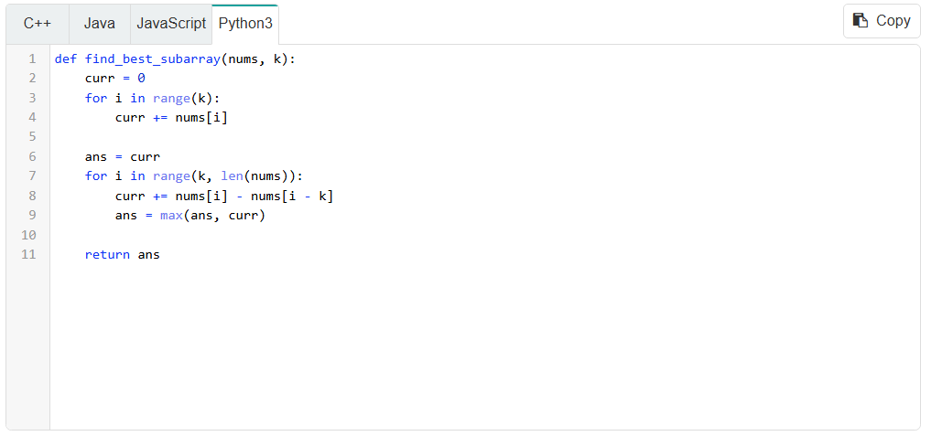
The total for loop iterations is equal to $n$, where $n$ is the length of nums, and the work done in each iteration is constant, giving this algorithm a time complexity of $O(n)$, using $O(1)$ space.

Closing notes
Sliding window is extremely common and versatile as a pattern. We only scratched the surface here because many sliding window problems will also need to use a hashmap, which we will talk about in the hashing chapter. After learning about hashmaps, we'll look at some more sliding window problems. In the meantime, test your knowledge by solving the upcoming practice problems.

